**Experiment 8**

**Aim: -** Create an application in which user is allowed to upload the file on the server.

**Code: -**

1. **Webform1.aspx**

<%@ Page Language="C#" AutoEventWireup="true" CodeBehind="WebForm1.aspx.cs" Inherits="Lab8B.WebForm1" %>

<!DOCTYPE html>

<html xmlns="http://www.w3.org/1999/xhtml">

<head runat="server">

<title></title>

<script type="text/javascript">

function showpreview(input) {

if (input.files && input.files[0]) {

var reader = new FileReader();

reader.onload = function (e) {

document.getElementById('imgpreview').setAttribute('style', 'visibility: visible;');

document.getElementById('imgpreview').setAttribute('src', e.target.result);

}

reader.readAsDataURL(input.files[0]);

}

}

</script>

</head>

<body>

<form id="form1" runat="server">

<div>

<asp:FileUpload ID="FileUpload1" runat="server" onchange="showpreview(this);" />

<br />

<p>Please attach a png or jpeg image of less than 25000 bytes</p>

<br />

<asp:Button ID="Button2" runat="server" Text="Upload file" Width="131px" OnClick="Button2_Click" />

<br />

<img id="imgpreview" height="200" width="200" src="" style="border-width: 0px; visibility: hidden; " />

</div>

</form>

</body>

</html>

1. **WebForm1.aspx.cs**

using System;

using System.Collections.Generic;

using System.Linq;

using System.Web;

using System.Web.UI;

using System.Web.UI.WebControls;

namespace Lab8B

{

public partial class WebForm1 : System.Web.UI.Page

{

protected void Page_Load(object sender, EventArgs e)

{

}

protected void Button2_Click(object sender, EventArgs e)

{

if (FileUpload1.HasFile)

{

if (FileUpload1.PostedFile.ContentType == "image/jpeg" || FileUpload1.PostedFile.ContentType == "image/png")

{

if (FileUpload1.PostedFile.ContentLength <= 25000)

{

FileUpload1.PostedFile.SaveAs("D://IT027//WT//lecture1//lecture1//upload_doc//" + FileUpload1.FileName.ToString());

Response.Write("File saved");

}

else

Response.Write("Attach a smaller file");

}

else

Response.Write("Attach an image only");

}

else

Response.Write("Please attach a file");

}

}

}

1. **Output**

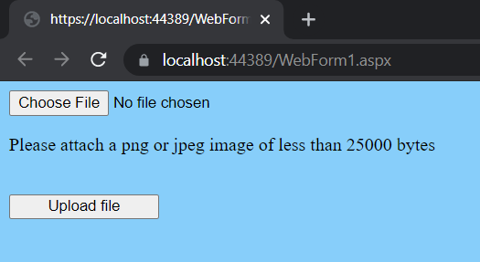

Fig 1. Layout

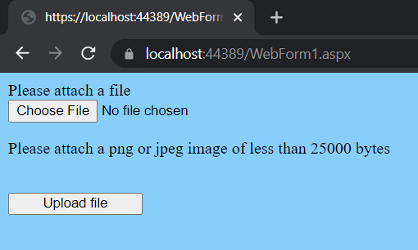

Fig 2. Error

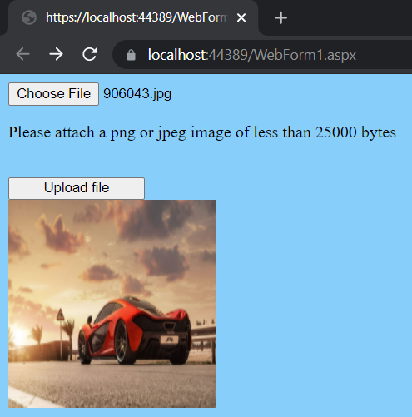

Fig 3. Uploading Image